BE 5.1 explicit tuple serialization

# (Accommodates both AS and BE-X/BEAST)

Ashwin Jayaprakash, May 15, 2012

### Components that use concept/event to/from external format:

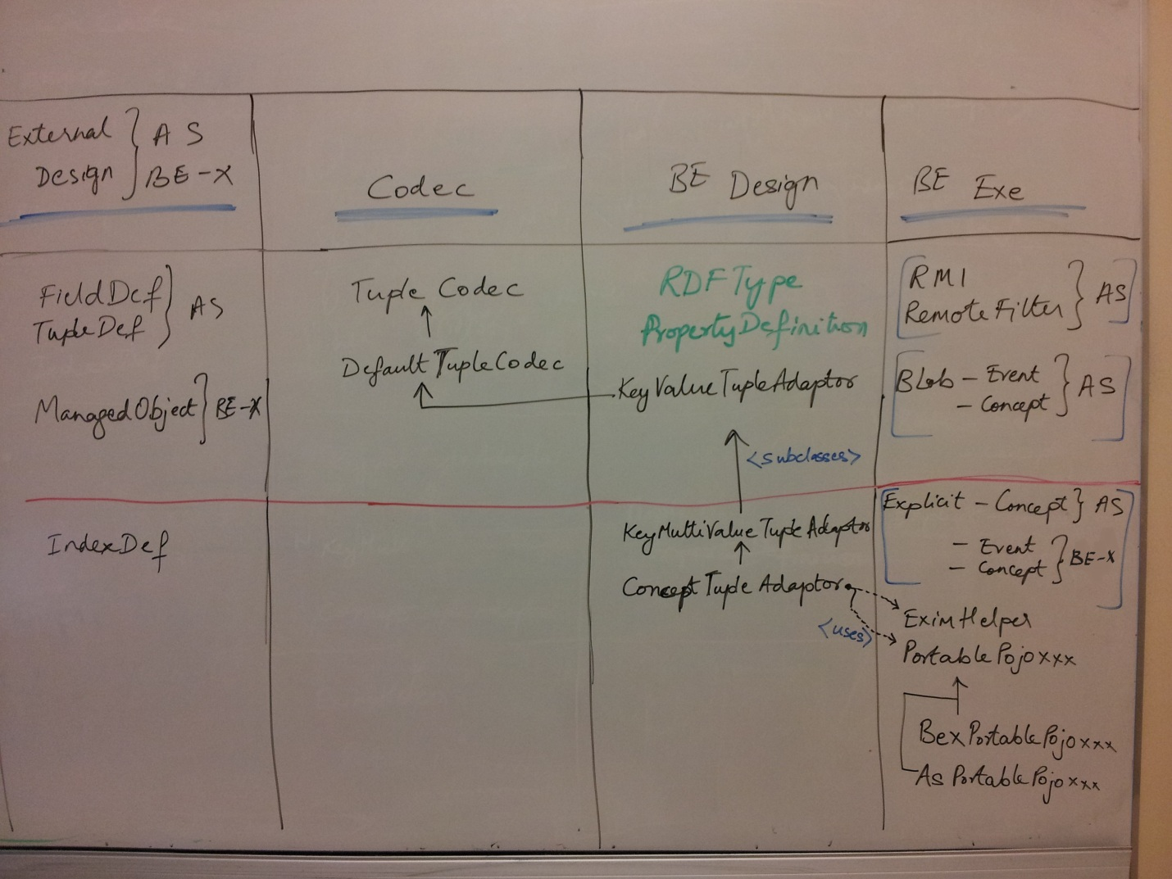

### Classes that allow AS/BEAST to use a lot of the same code:



 